
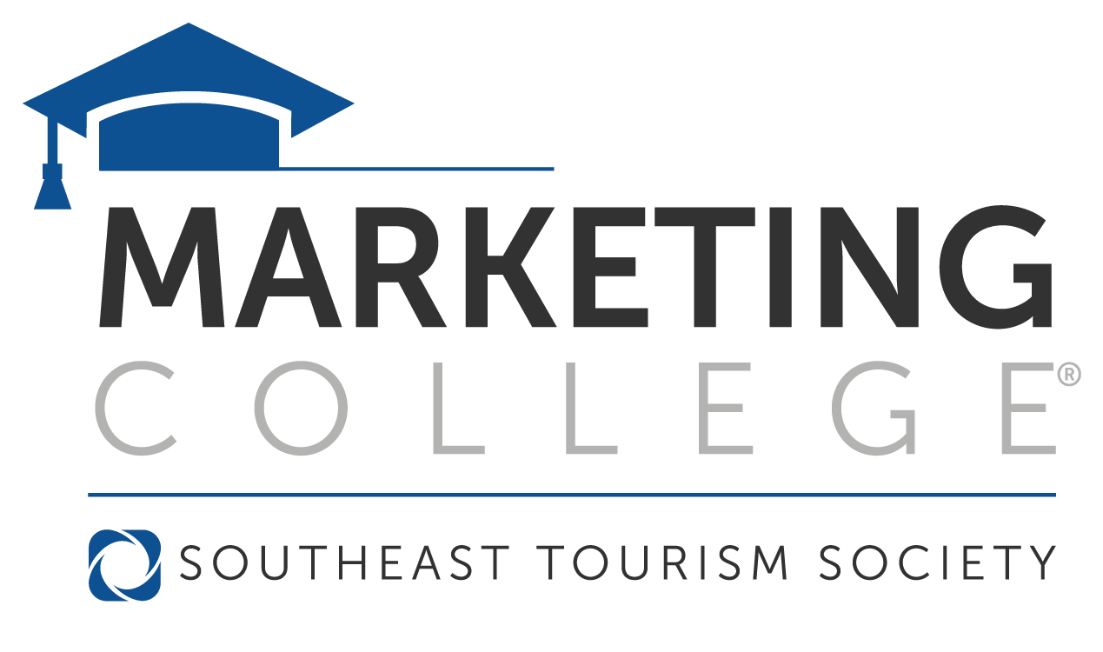
2026 Scholarship Application
May 31 – June 5, 2026
Macon, Georgia

Overview
The Tennessee Department of Tourist Development is pleased to announce they are offering DMO partners an opportunity to apply for a scholarship to Southeast Tourism Society’s Marketing College®. Marketing College® students participate in a curriculum of courses designed to teach marketing techniques from all facets of the tourism industry. Upon completion of the three-year Marketing College® curriculum, students receive a Travel Marketing Professional (TMP) certification.

TDTD will award up to 25 scholarships. As Marketing College® is a three-year program, individuals who have been awarded a scholarship from TDTD in the past will have priority the remaining year(s) they apply. Awards for individuals in years one, two or three will cover tuition, including most meals. All other expenses, including lodging, are the responsibility of the applicant’s organization.

Eligibility Requirements
- Applicant must be currently employed by a Tennessee Destination Marketing Organization (Convention & Visitors Bureau, Chamber of Commerce, Regional Tourism Organizations, etc.)
- Applicant must be a paid staff member employed by current organization for at least 1 year
(Applicants from at-risk or distressed counties may have been employed for less than 1 year)
- Applicant must provide:
  - One letter of recommendation from a senior level position within the organization
(If applicant is CEO/President, it should be from the board president)
  - One letter of recommendation from a leader within the tourism industry (not TDTD staff)

Please type your responses below.

A. Personal Data

Name:

Organization:

Organization address:

City:

State:

Zip:

Business Phone:

Email:

B. Professional Data

Current position with organization:

Number of years in position:

Professional goals:

C. 250 words or less on why I feel I will benefit from attending Marketing College:

D. Please provide reasons for financial aid.

E. Does your organization have an educational budget?
If yes, please list amount:

F. Have you attended Marketing College previously?
If yes, when, and how many years?

Thank you for your interest in attending Marketing College. Contact Andi.Grindley@tn.gov for all questions pertaining to your scholarship application.

Typed application and supporting materials must be received by Friday, March 20, 2026. Please return application and supporting material to andi.grindley@tn.gov.

Scholarship recipients will be notified of their selection no later than March 27, 2026.

