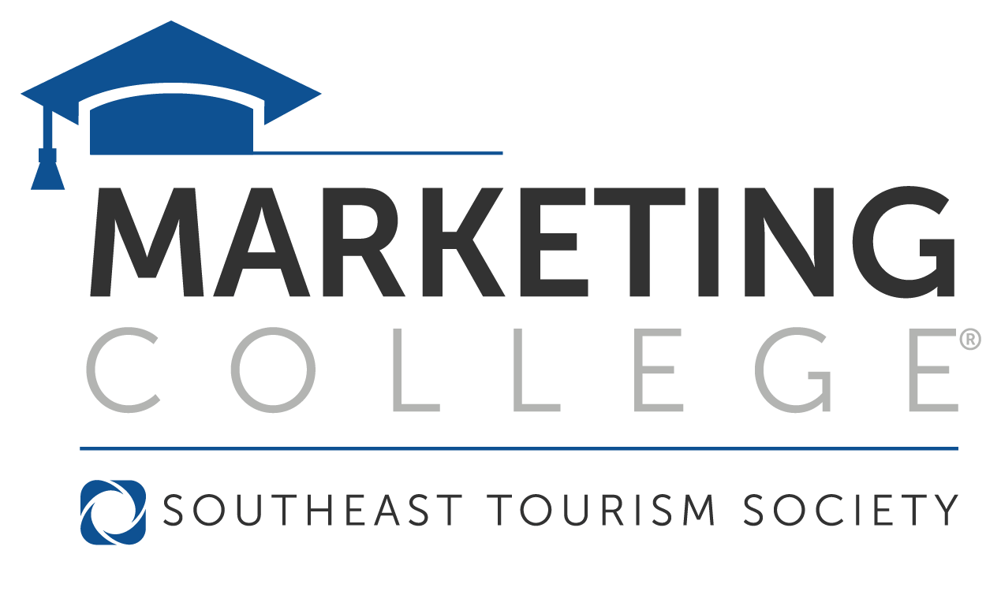

**2025 Scholarship Application**

**June 1 – 6, 2025**

**Macon, Georgia**

**Overview**

The Tennessee Department of Tourist Development is pleased to announce they are offering DMO partners an opportunity to apply for a scholarship to Southeast Tourism Society’s Marketing College®. Marketing College® students participate in a curriculum of courses designed to teach marketing techniques from all facets of the tourism industry. Upon completion of the three-year Marketing College® curriculum, students receive a Travel Marketing Professional (TMP) certification.

TDTD will award up to 20 scholarships. As Marketing College® is a three-year program, individuals who have been awarded a scholarship from TDTD in the past will have priority the remaining year(s) they apply. Awards for individuals in years one, two or three will cover tuition, including most meals ($1,745). Alumni courses will not be offered this year. All other expenses, including lodging, are the responsibility of the applicant’s organization.

**Eligibility Requirements**

* Applicant must be currently employed by a Tennessee Destination Marketing Organization (Convention & Visitors Bureau, Chamber of Commerce, Regional Tourism Organizations, etc.)
* Applicant must be a paid staff member employed by current organization for at least 1 year

(Applicants from at-risk or distressed counties may have been employed for less than 1 year)

* Applicant must provide:
  + One letter of recommendation from a senior level position within the organization

(If applicant is CEO/President, it should be from the board president)

* + One letter of recommendation from a leader within the tourism industry (not TDTD staff)

***Please type your responses below.***

**A. Personal Data**

Name:

Organization:

Organization address:

City:

State:

Zip:

Business Phone:

Email:

**B. Professional Data**

Current position with organization:

Number of years in position:

Professional goals:

**C. 250 words or less on why I feel I will benefit from attending Marketing College:**

**D. Please provide reasons for financial aid.**

**E. Does your organization have an educational budget?**

**If yes, please list amount:**

**F. Have you attended Marketing College previously?**

**If yes, when, and how many years?**

Thank you for your interest in attending Marketing College. All questions pertaining to your scholarship application should be addressed to Andi Grindley at [andi.grindley@tn.gov](mailto:andi.grindley@tn.gov) or 615-741-7994.

Typed application and supporting materials must be received by **March 28, 2025**. Please return application and supporting material to [andi.grindley@tn.gov](mailto:andi.grindley@tn.gov).

Scholarship recipients will be notified of their selection no later than **April 4, 2025**.